1)Install git.

2)Create a repo in github with README.md and .ignore file.

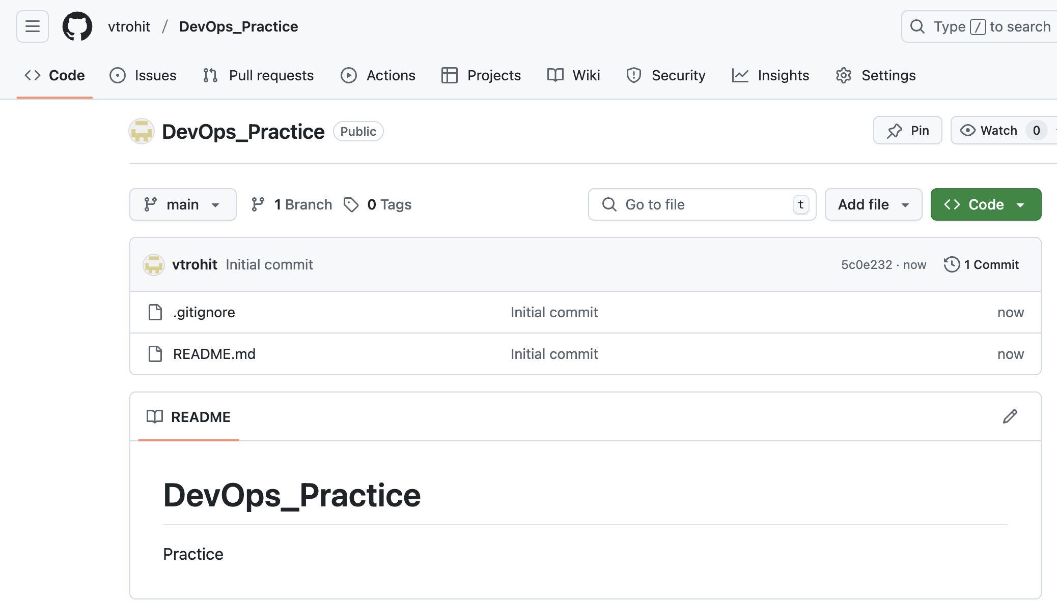

3)Clone the created repo to local.

4)Create two files in local repo.

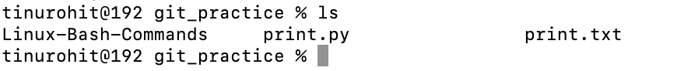

5)Commit two files and push to central Repository.

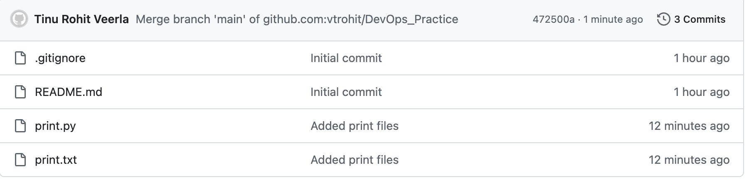

6)Create a branch in local and create a sample file and push to central.

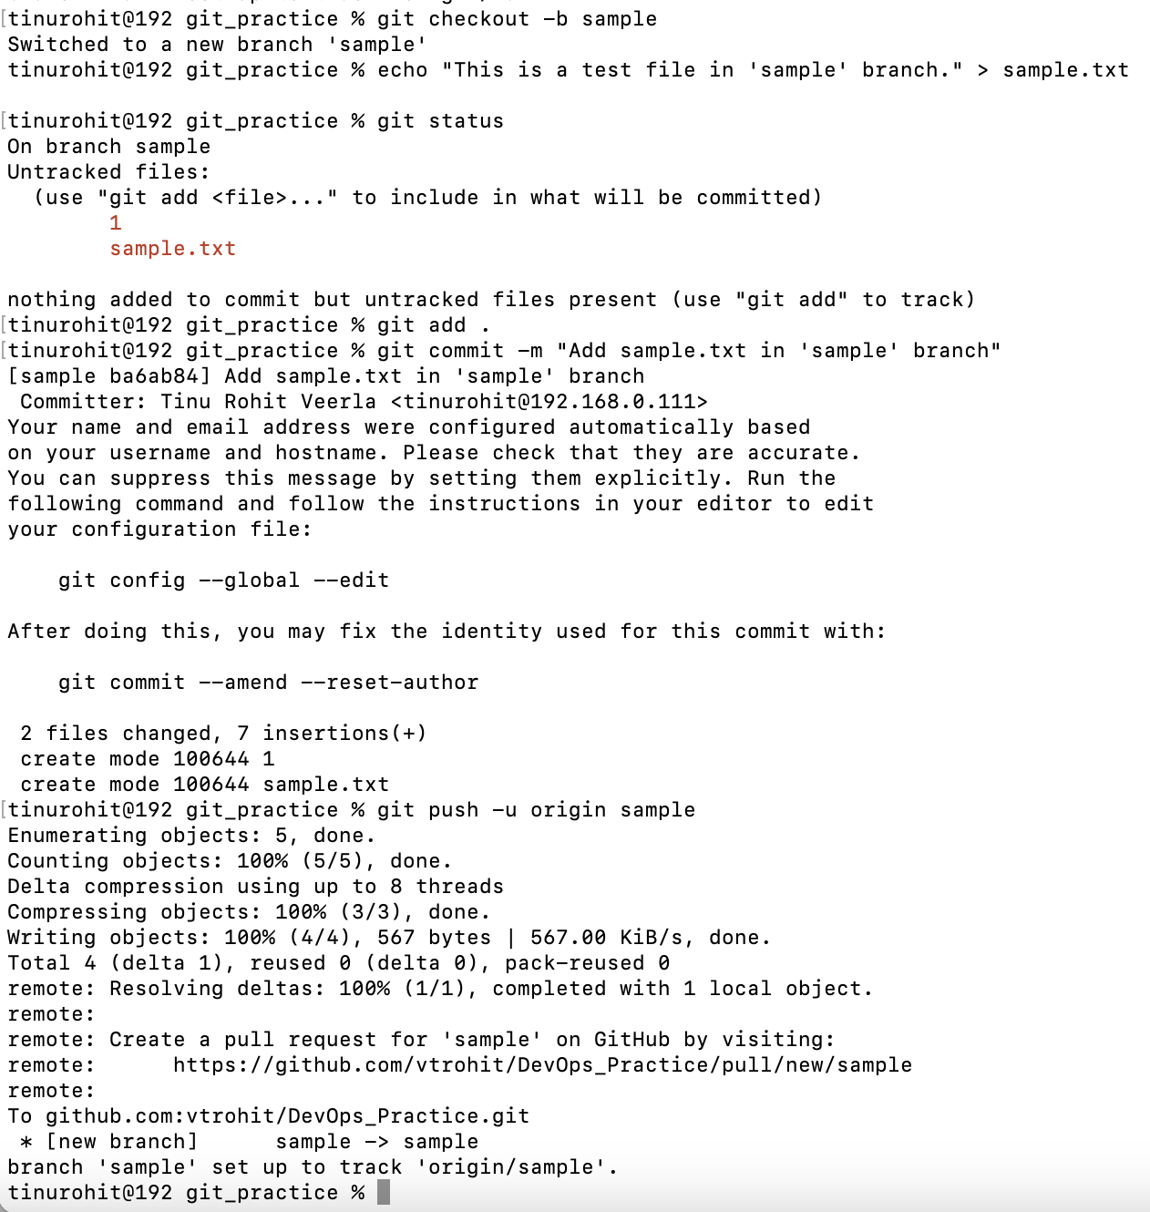

7)Create a branch in github and clone that to local.

8)Merge the created branch with master in git local.

9)Merge the created branch with master in github by sending a pull request.

10)create a file in local and send that to branch in github.

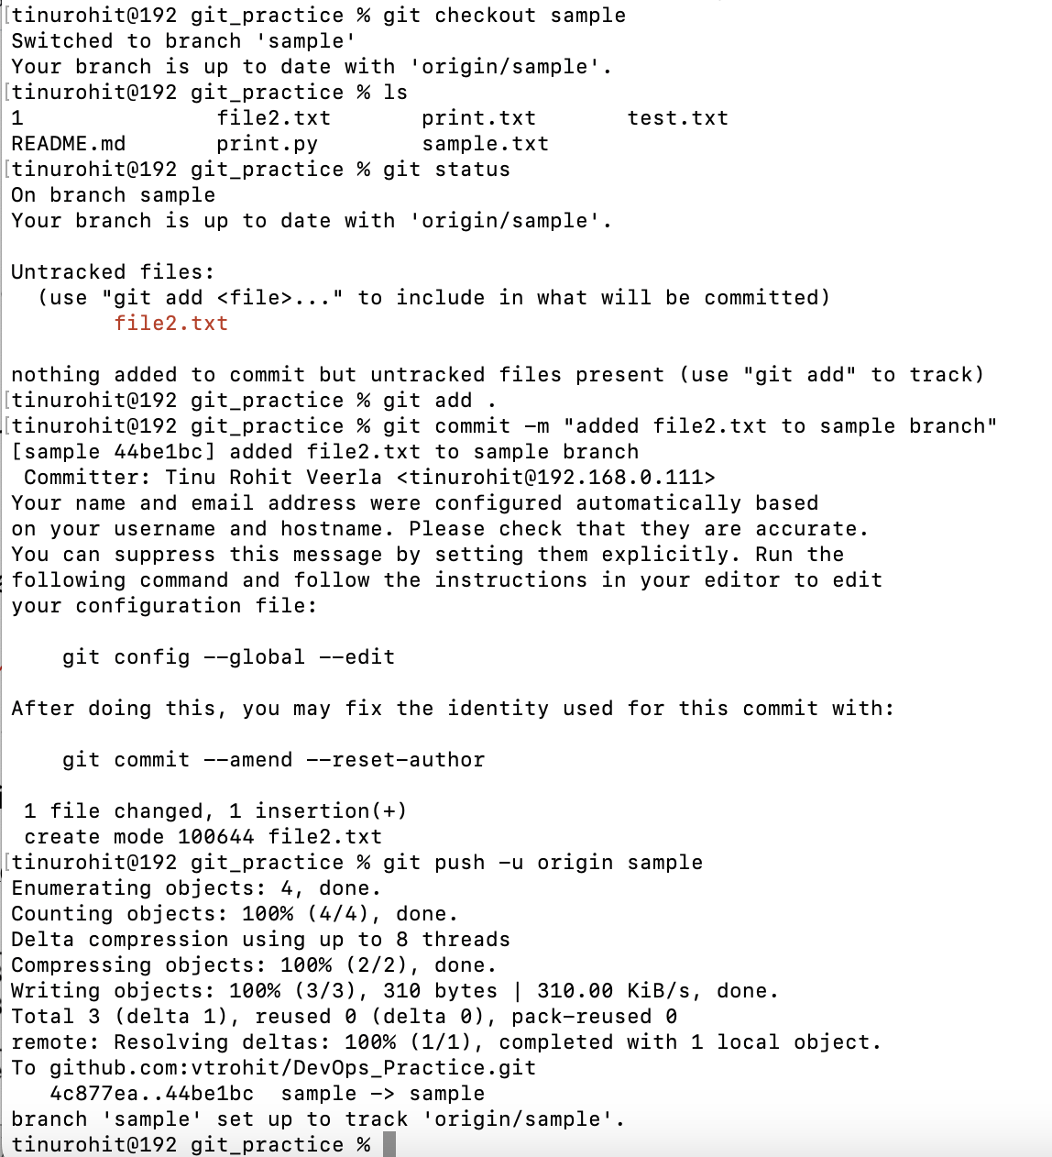

11)clone only a branch from github to local.

12)create a file with all passwords and make that untrackable with git.

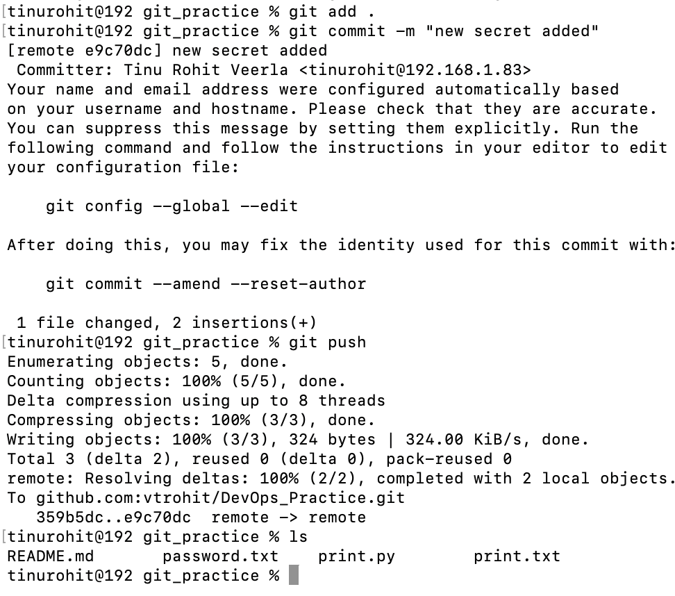

13)make a commit and make that commit reset without savings changes.

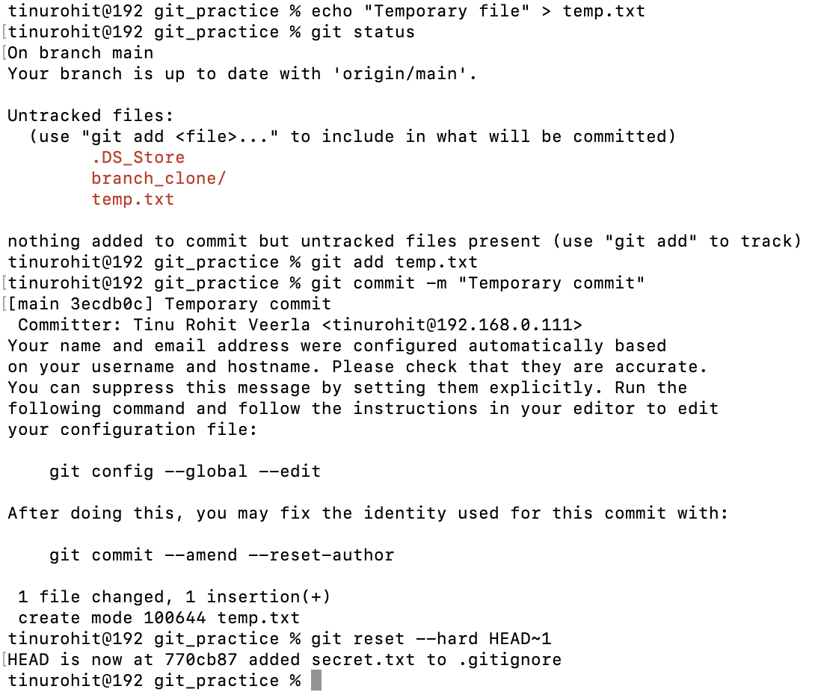

14)Revert a commited commit to the older version.

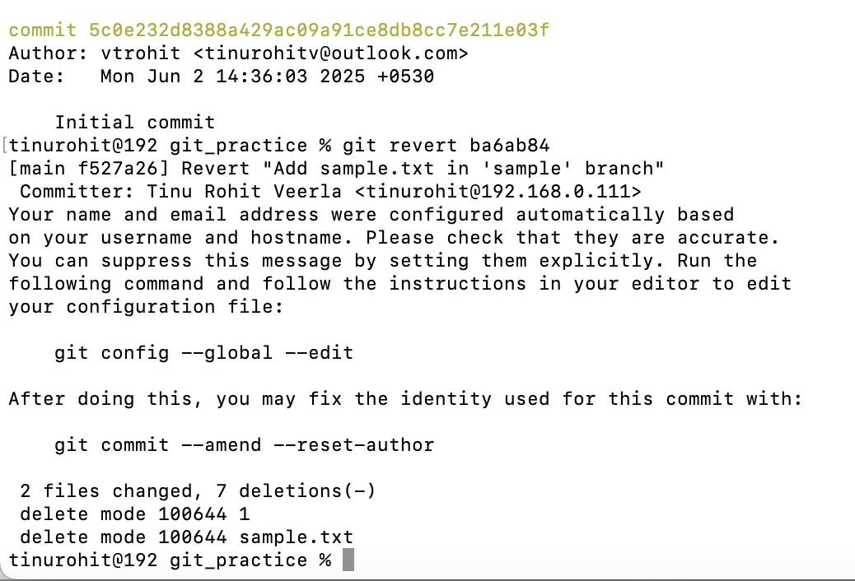

15)push a file to stash without savings the changes and work on another file.

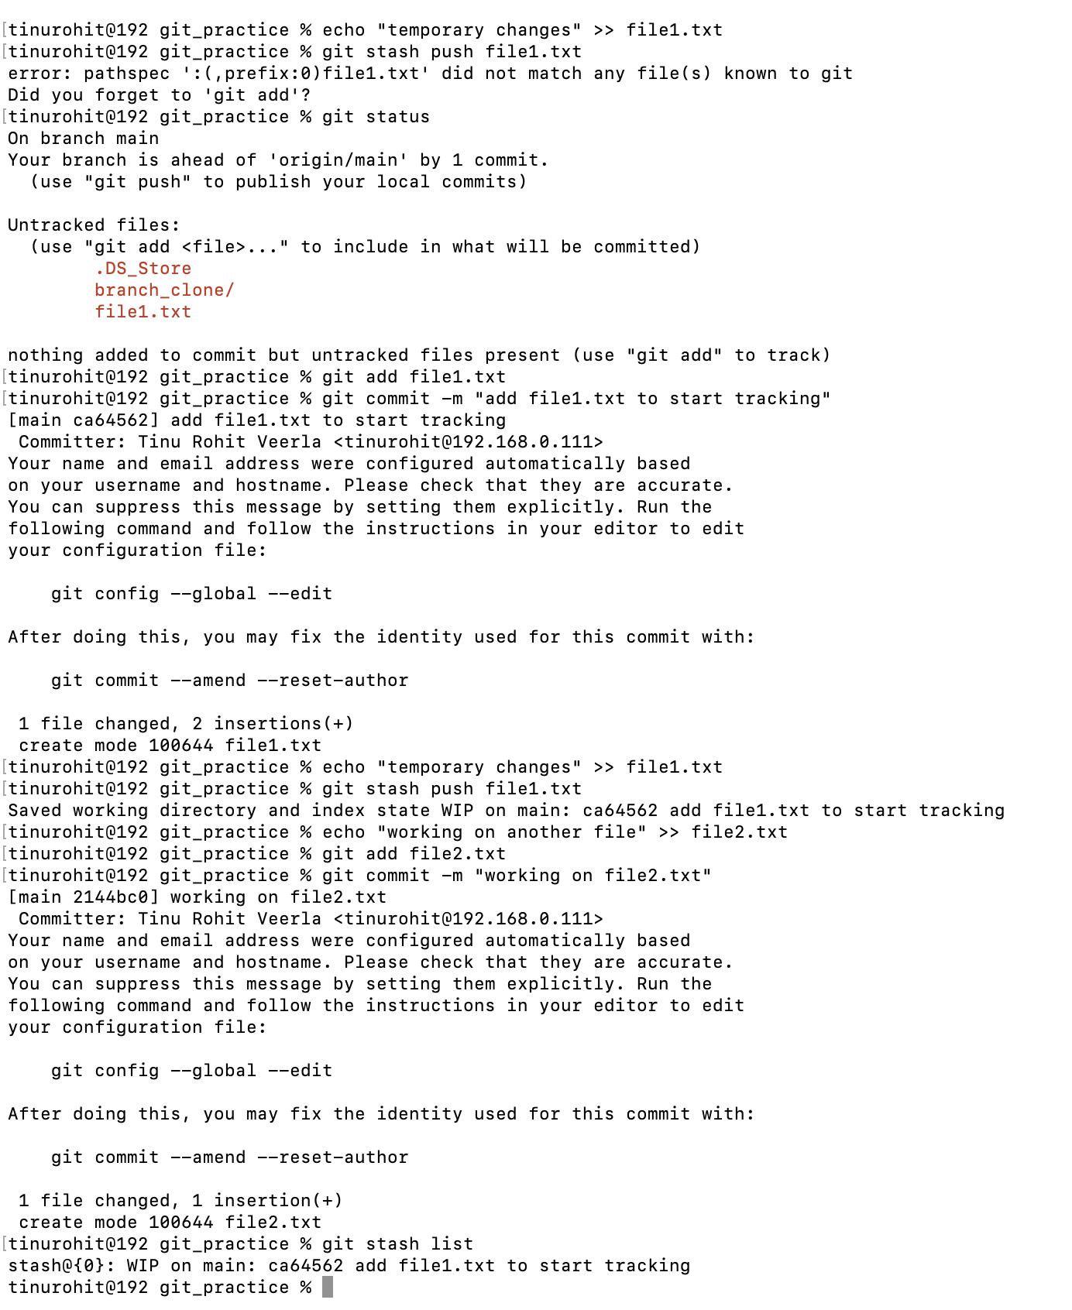

16)undo the stash file and start working on that again.

17)generate a ssh-keygen and configure into github.

18)configure webhooks to github.

19)basic understanding of .git file.

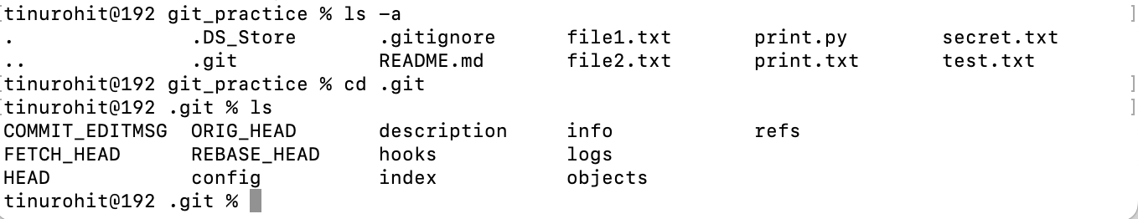

.git is a hidden folder inside project directory that stores all information that git needs to track projects history and manage version control. When we initialize git init or clone a repo, git creates .git folder.

20)Check all the logs of git.

21)Rename the commit message.

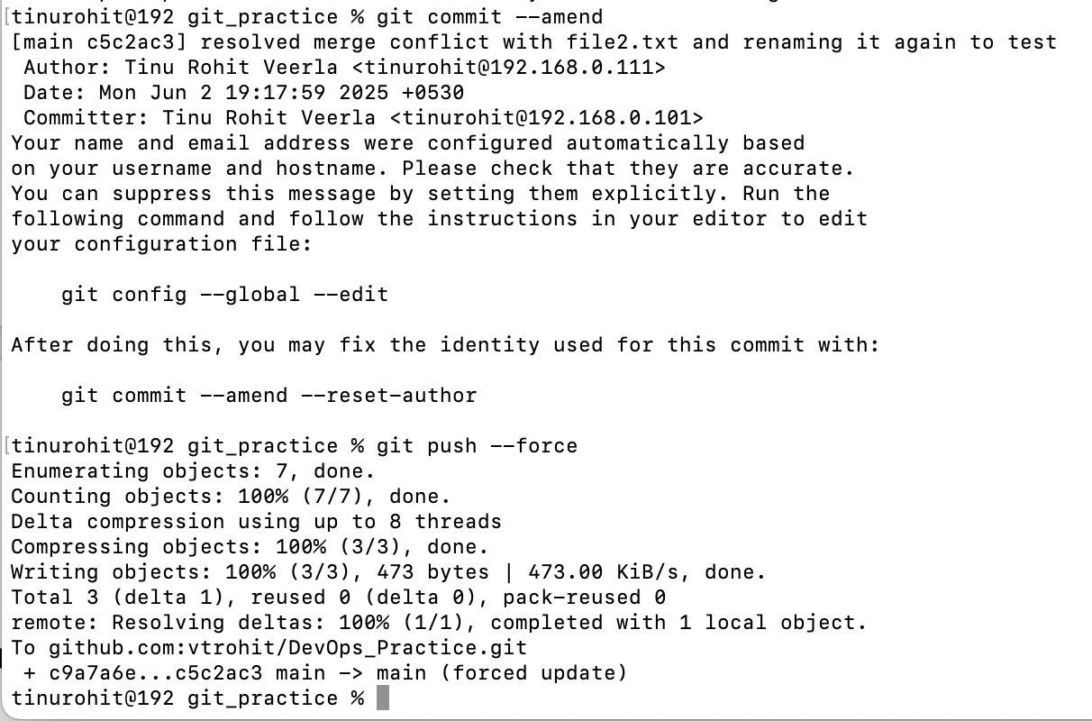

22)Merge multiple commits into single commit.

